Colle les bonnes étiquettes en dessous des personnages
LA FAMILLE SIMPSON
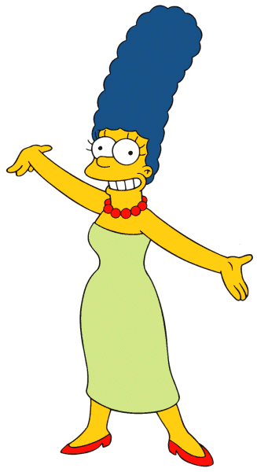 |  | 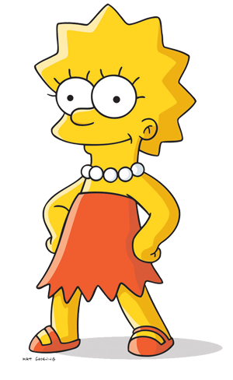 |  | 
LES INDESTRUCTIBLES
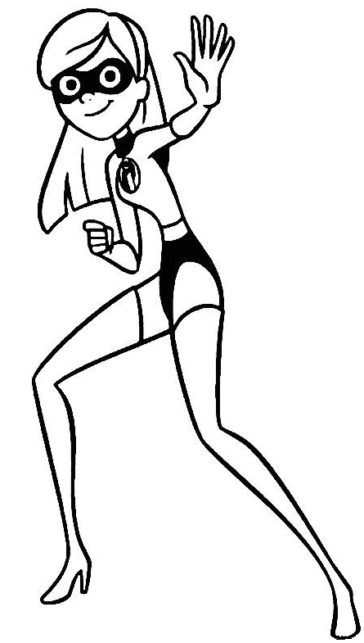 |  |  | 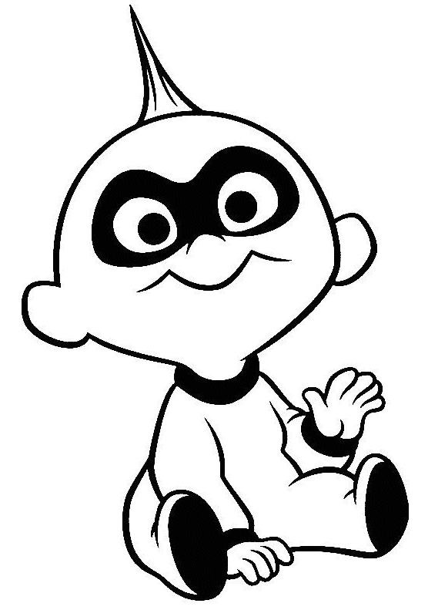 |  | 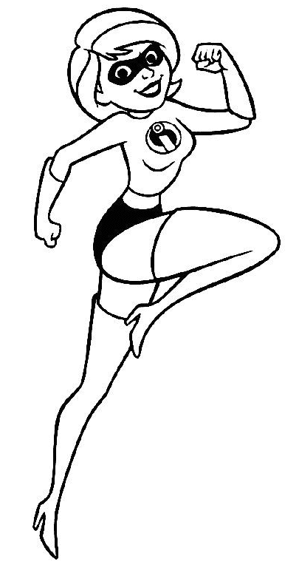 |  | 
The father |  | The mother |  | The baby |  | The brother |  | The sister
The father |  | The mother |  | The baby |  | The brother |  | The sister

The father | The mother | The baby | The brother | The sister
The father | The mother | The baby | The brother | The sister

