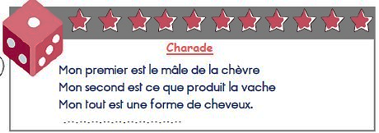**CHARADE ET SUDOKU VENDREDI 12 JUIN**

**Réponse** : …………………………………………………………

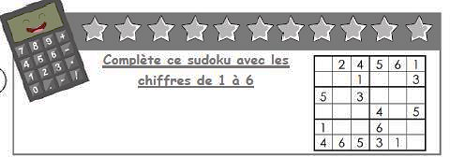

|  |  |  |  |  |  |
| --- | --- | --- | --- | --- | --- |
|  | **2** | **4** | **5** | **6** | **1** |
|  |  | **1** |  |  | **3** |
| **5** |  | **3** |  |  |  |
|  |  |  | **4** |  | **5** |
| **1** |  |  | **6** |  |  |
| **4** | **6** | **5** | **3** | **1** |  |