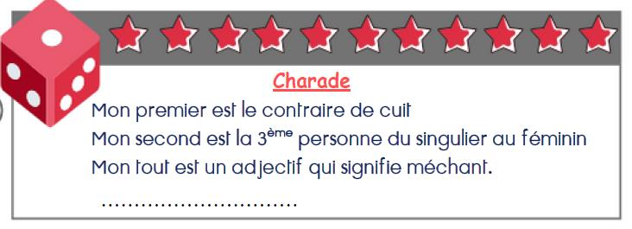**CHARADE ET SUDOKU JEUDI 11 JUIN**

**Réponse** : …………………………………………………………

|  |  |  |  |  |  |
| --- | --- | --- | --- | --- | --- |
|  | **2** | **3** | **6** |  |  |
|  | **6** |  | **3** |  |  |
| **6** |  |  |  |  | **3** |
| **5** |  |  |  |  | **2** |
|  |  | **6** |  | **4** |  |
|  |  | **4** | **5** | **3** |  |

